Project 4

**Git Project:**

Task1: create a repository in github

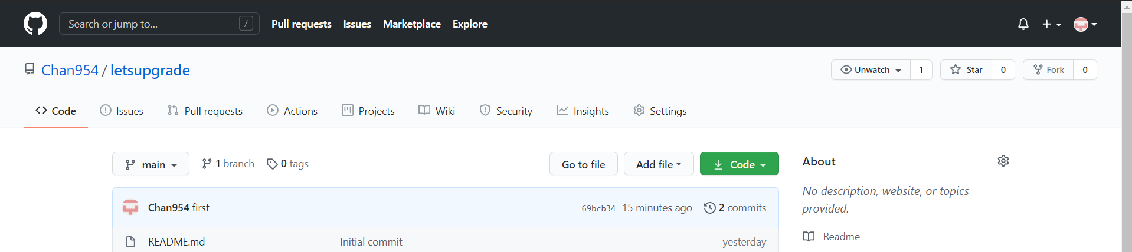

Executing git int, config commands

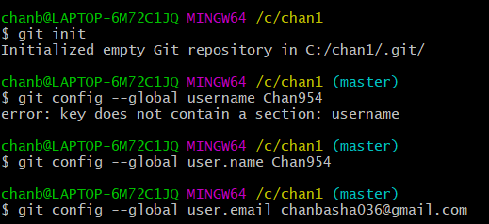

Task2: open git bash and clone contents from remote repository

Executing clone command and the folder in local repository

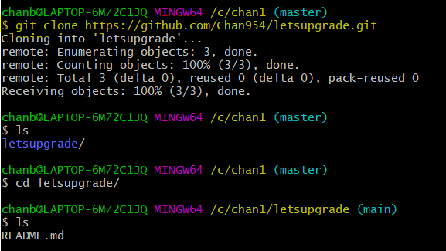

Task3: create a file in the local space and push it to the remote repository

Adding file

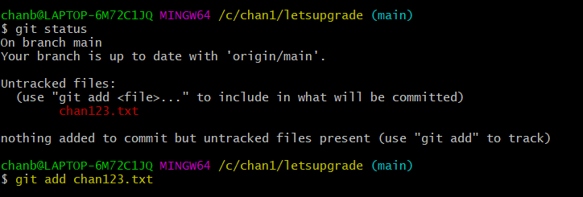

Commiting file

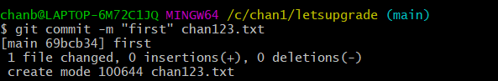

Pushing a file

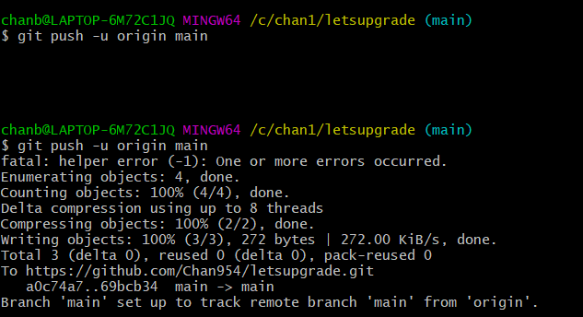

the file in remote repository

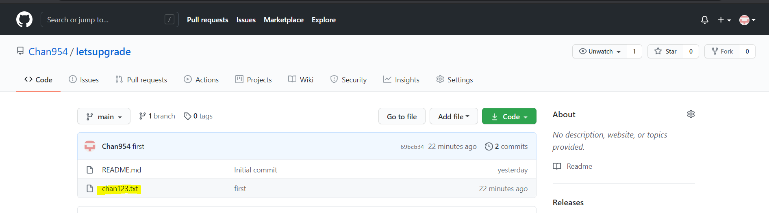

Task4: Branching and merging

Git branch

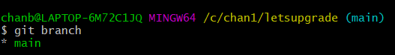

Git branch branchname

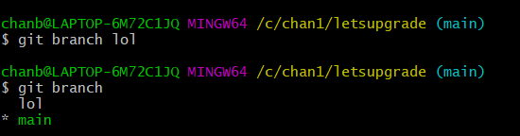

Git checkout branchname

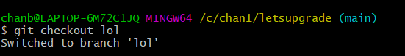

Git merge branchname

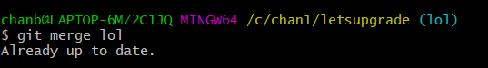

Git branch -d branchname

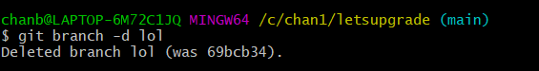

Git branch -D branchname

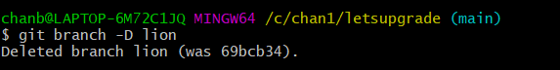

Git checkout -b branchname

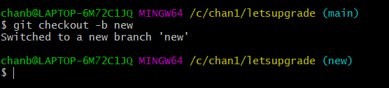

Git log

